**Google Cloud platform project**

**How to use Google Cloud SQL with Google Cumpute engine**

**By: Sadeem Khalid Alqarni**

1. **Create Database**
2. Go to SQL section

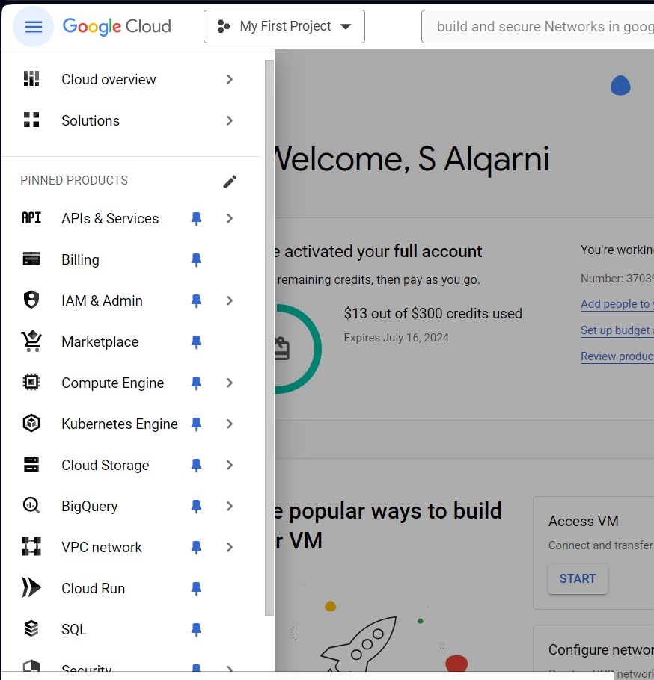

1. **Click on**

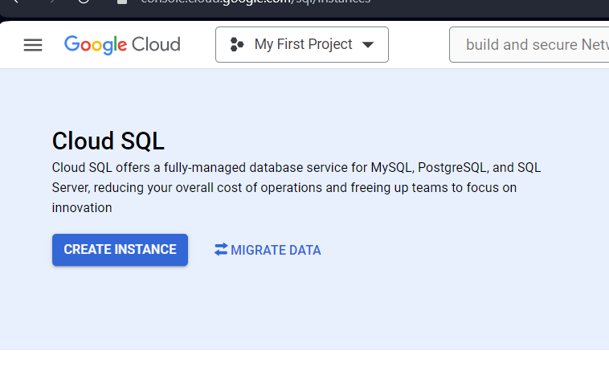

1. Give your instance name and click on no password

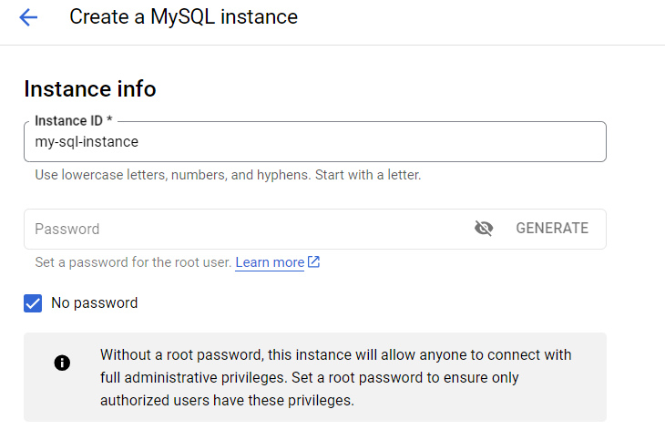

1. Give it a Region.

1. Click on **SHOW CONFIGURATION OPTIONS**

1. **Click on Storage and choose a Storage Capacity**

1. **Click on CREATE INSTANCE**

**Now your instance is created!**

1. **Now go to Compute Engine section**

1. Copy the External IP of your instance

1. **Go back to the SQL section**

1. Click on your instance

1. click on **connections**

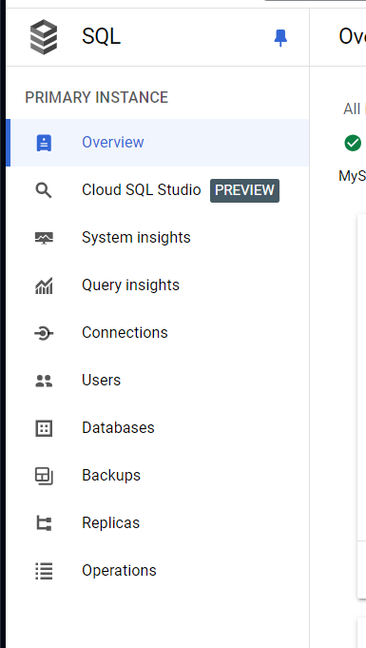

1. **click on NETWORKING**

1. click on **ADD A NETWORK**

1. give it a name, paste the External IP and click **DONE**

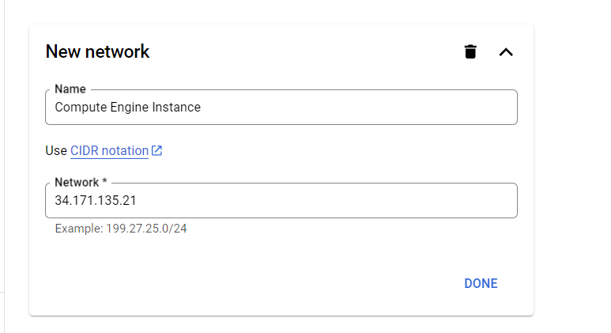

1. click **Save**

1. go to **Users**

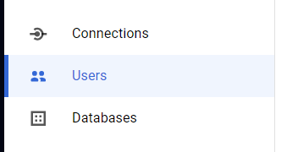

1. **click on this icon**

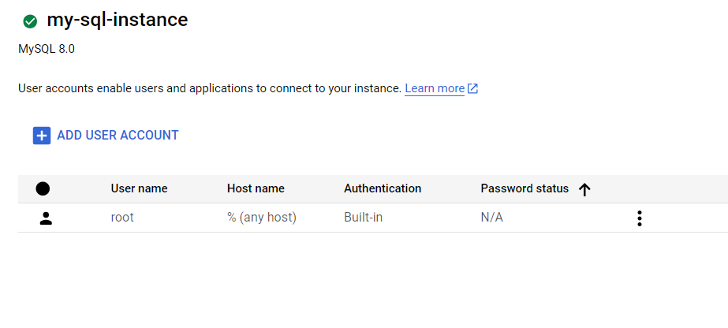

1. click on **Change password**

1. Change the rootpassword and click **OK**

